En liten berättelse från en partner i projektet Stronger Together:
Work Journey within the “Stronger Together” Project
In August, Sandijs, a resident of our “Vanags” group apartment in Valmiera, celebrated his 44th birthday. “Vanags” has been his home for the past seven years, since we opened the group apartment, which gives people with intellectual disabilities the opportunity to live as independently as possible. It supports them in developing self-care skills and learning every day and other skills, including those needed to enter the labor market. We congratulate Sandijs and are proud of his determination and desire to make his life more fulfilling – to learn, work and contribute to the life of his local community.
Sandijs is also one of the participants in the “Stronger Together” project, representing employees. He has been working as a laundry worker at the state social care center “Rūja” since 2019. It is a part-time job, in line with his abilities. However, the young man’s desire to stay active means he does not want to sit idle. He was looking for additional employment opportunities, and the project proved to be a perfect fit for his needs. It helps people with disabilities enter the labor market by providing training and support to both sides – employers and employees. With the support of a mentor, Sandijs can therefore fill the second half of his working day by carrying out ground’s maintenance work for the local housing cooperative “Annas 2”.
Like many other people with intellectual disabilities, Sandijs finds it difficult to maintain his attention and interest for long periods of time. That is why he particularly enjoys this additional job, as his tasks vary. Most of the time, he is responsible for keeping the paved areas in the courtyard clean, but there is more to it than that – he removes weeds from paving and flower beds, collects broken branches and rakes fallen leaves from the lawn. And, as it happens, there was certainly no shortage of work after the recent storm!
“I like having things to do. I really like it when someone tells me that I have done my job well. It is good that I am not alone and that there is someone I can ask how something should be done. I also like trying new things,” says Sandijs.
Importantly, the employer also benefits greatly from this arrangement. Finding workers for property maintenance in the city is very difficult. The solution developed and piloted during the project – “Employee as a Service” – works as follows: the service provider, the social enterprise SIA “Samariešu darbnīcas”, enters into an agreement with an employer to provide a specific service that the employer needs. In this case, “Annas 2” needs grounds maintenance services, which are provided by SIA “Samariešu darbnīcas” by employing Sandijs, who can carry out the work.
As the service provider, “Samariešu darbnīcas” understands the potential employee’s abilities and support needs. The employer is also familiar with these needs, having received training and/or support. The employer does not need to establish a permanent employment relationship, while still having access to a worker who can carry out specific tasks.
“This is one way of integrating people with disabilities into the labor market while providing employers with knowledge and support. By getting to know a person and understanding their support needs, employers may later choose to employ them permanently, without the involvement of a social enterprise. However, this initial stage – identifying opportunities, getting to know the abilities of people with disabilities and making use of available support measures – is extremely important,” emphasizes project manager Inga Brente-Mieze.
Autumn is approaching, bringing fallen leaves, followed by winter and the challenges that come with snow. Sandijs will certainly have no shortage of work!
The “Stronger Together” project is implemented within the framework of the Interreg Central Baltic Programme 2021–2027 and is co-financed by the European Union.
Central Baltic Programme Valmieras Attīstības aģentūra Latvijas Samariešu apvienība
#StrongerTogethe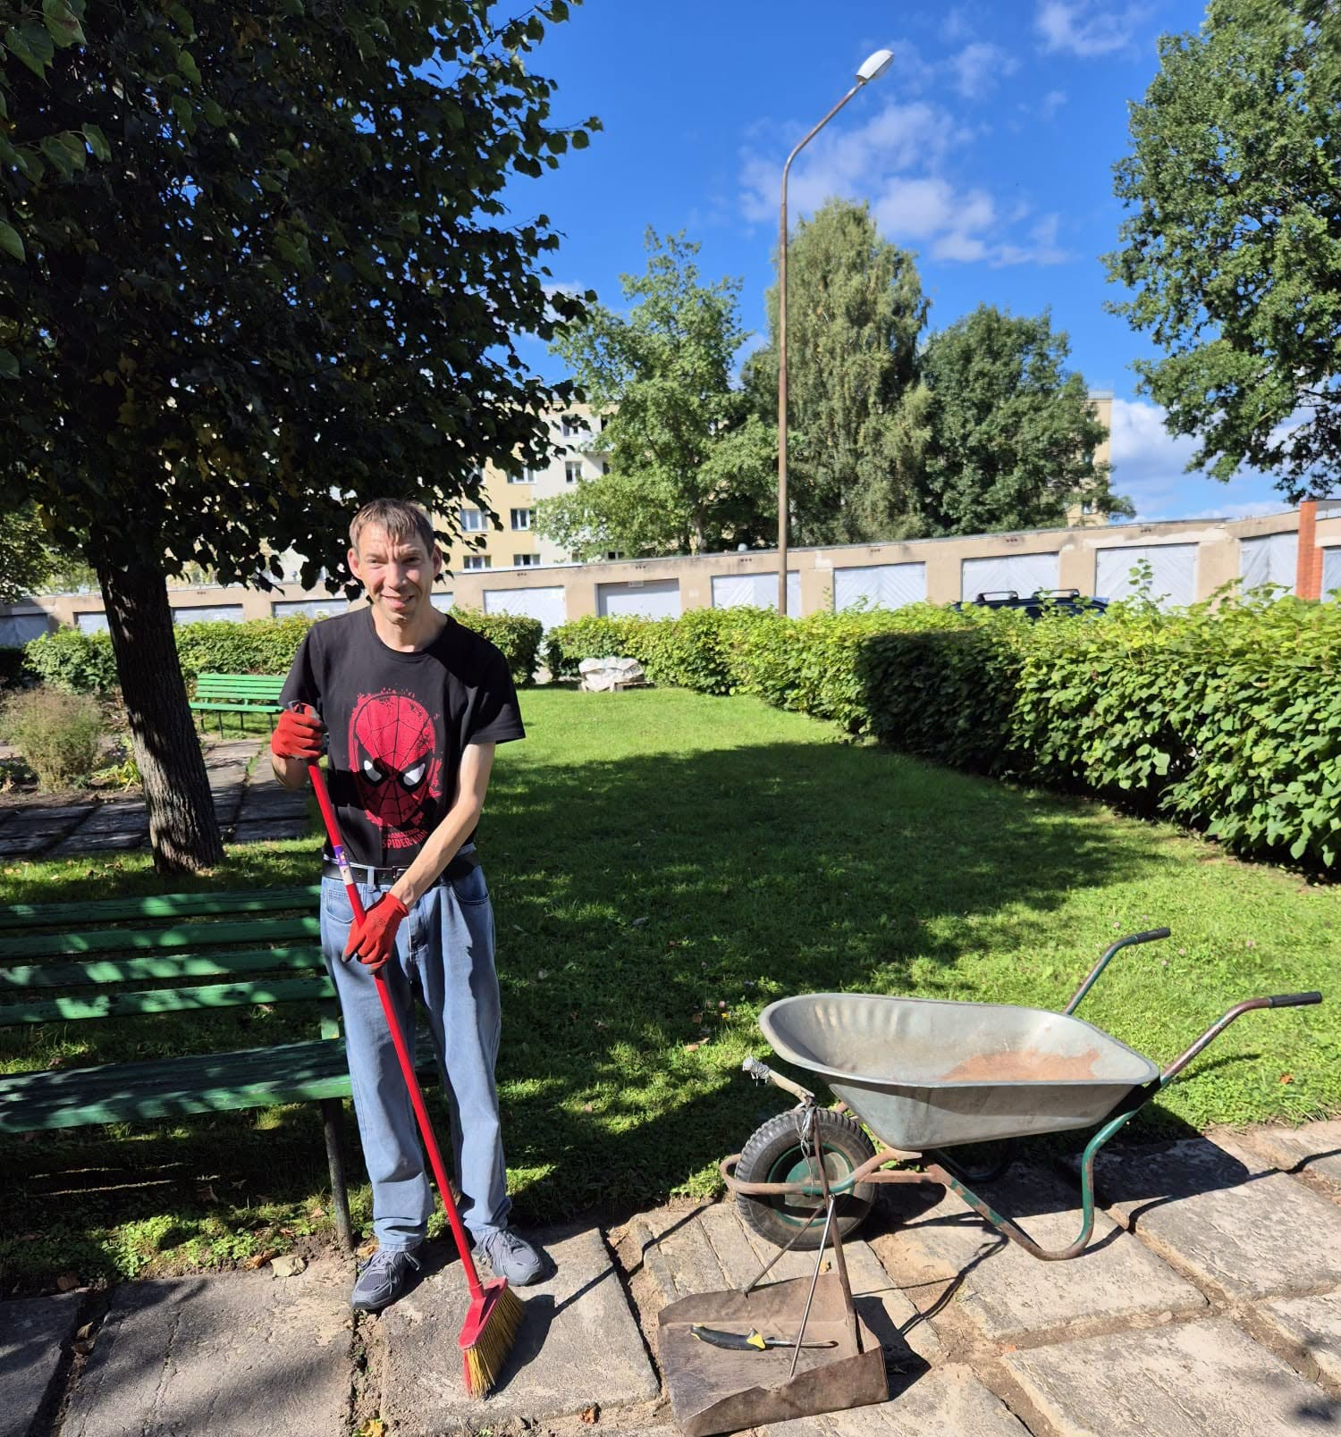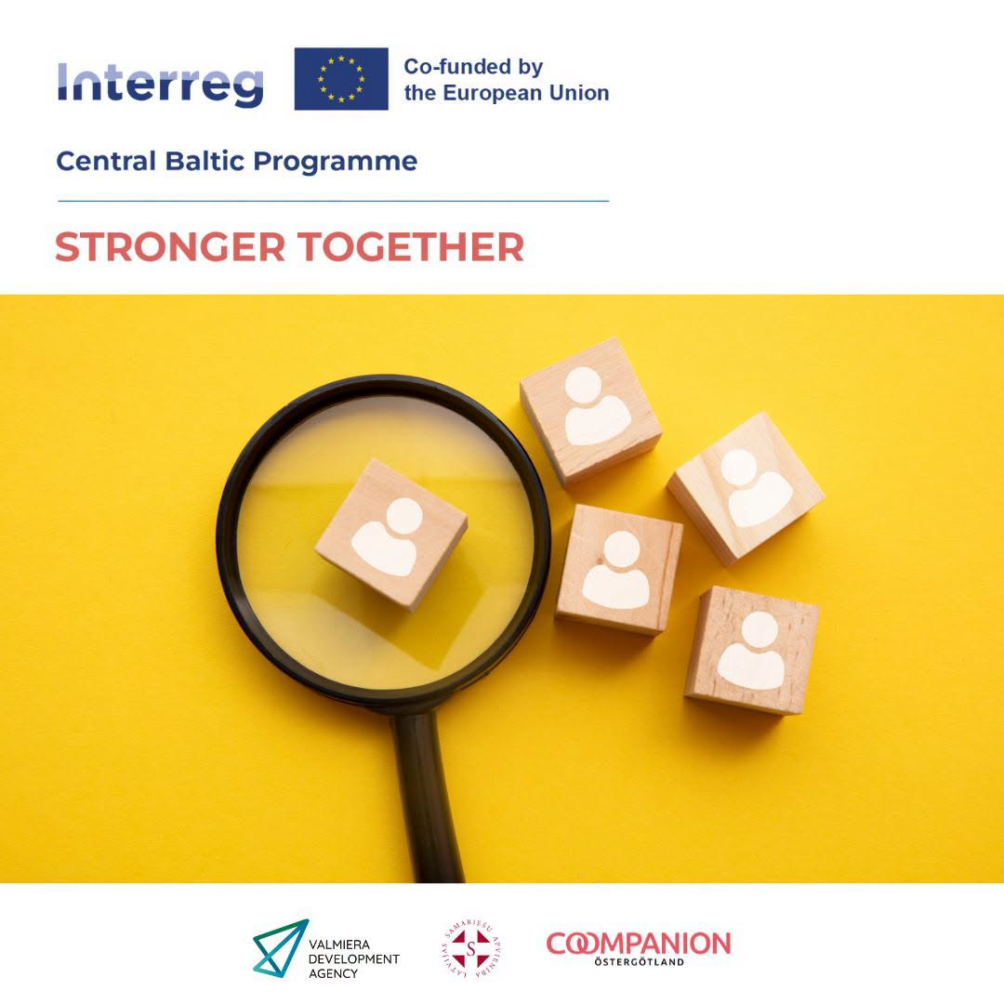r #CentralBaltic #Interreg

